Umega Lettings – Investment Sourcing Service
Our investment sourcing service joins the dots of property investment in Edinburgh for landlords new to property investment or those who already hold a property portfolio.

Property or Portfolio Healthcheck
If you already own investment properties we can carry out a property or portfolio ‘healthcheck’ with you to assess the performance of your current property(ies) in terms or the value, the rent, the level of equity held and any works that could be done to improve the value of your property(ies). At this point we can introduce you to a mortgage advisor and an accountant who can clarify the finer points for you. We have some fantastic financial models we can run with you to simplify things and help you work out your long-term investment goals and how to achieve them.
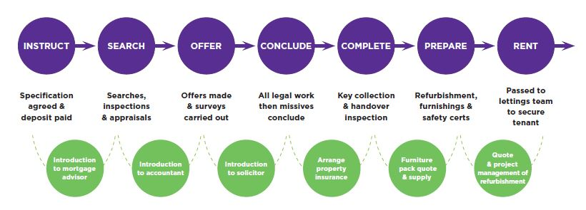
Search – Once we’ve helped you do your sums and you’re happy to proceed we will then agree the specification of our search with you then you can leave us to go out there and find you a suitable investment property. We’ll search on- and off-market and report back to you each time we find a property that we like and that meets your criteria. We’ll run each property through a financial appraisal to really simplify things for you and to allow easy comparison between properties. If there’s any refurbishment required we’ll also give you an estimate of the likely cost of this to build into your calculations.

Offer – Once we’re in agreement about a property we’ll work with you and your solicitor (we can introduce you to one) to make an offer for the property and hopefully we’re in luck! We’re very active in the market and have access to information on recent property sales so are well positioned to advise on a fair offer price. We always do our best to get you the best possible deal. We love good value! If any surveys are required as part of the offer we’ll sort these out (structural/damp/valuation).

Conclude – Normally it will take 4-8 weeks following a successful offer before you get the keys. During this time, we’ll work with solicitors to ensure a smooth handover from the current owner. If the property is currently rented out we’ll also spend this time dealing with the current agent to gather all relevant paperwork. We’ll also arrange a property insurance quote and can arrange a quote for furnishing the property if required. We can pull together quotes for any recommended upgrading (albeit we may have to wait until the last couple of weeks before completion until trades can access the property).

Complete & Prepare – On the day the property becomes yours we’ll collect the keys and inspect the property on your behalf. We project manage and line up any works or furnishings to be taken care of as quickly as possible once we have the keys and will get the property ready to be passed to the lettings team swiftly so that they can get it on the market and secure you a good tenant at a good rent, quickly.

We charge a fee of 1%+VAT (of the purchase price) for our investment service. We also charge a 10%+VAT project management fee for any works that are needed to prepare the property for letting.

